DOCKER EXPERIMENTS

EXPERIMENT – 17

AIM:
Create a Simple Python Flask API, Containerize the Application, Build & Push the Image using Docker and Deploy the Application using Kubernetes.
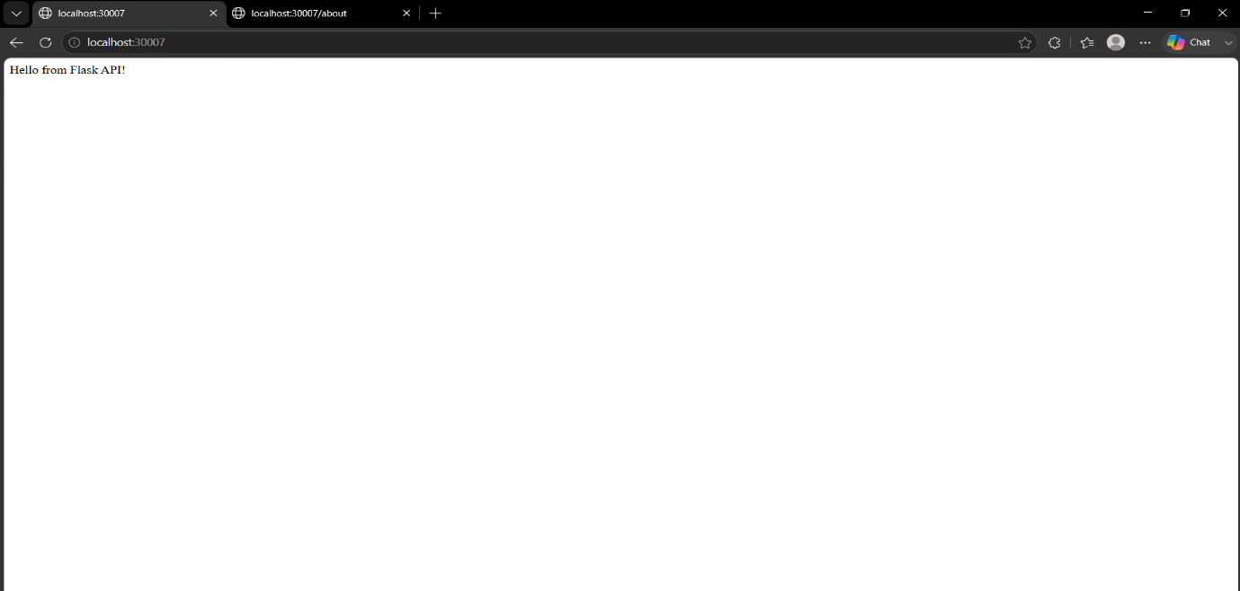

EXPERIMENT- 19

AIM:
Implement Continuous Deployment using GitHub Actions to deploy a Dockerized application.
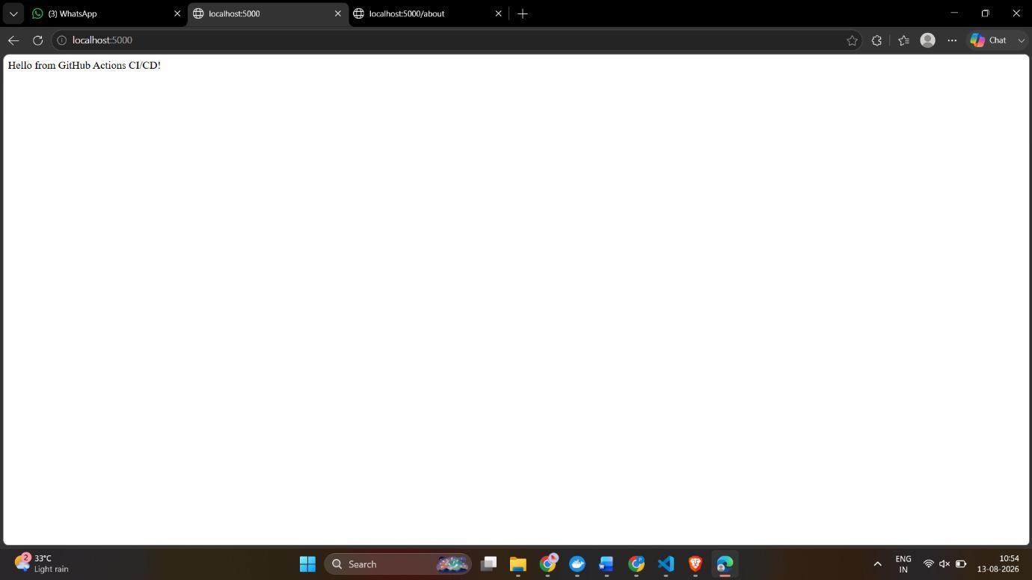

EXPERIMENT- 21

AIM:
Containerize a Python Flask Application Using Docker
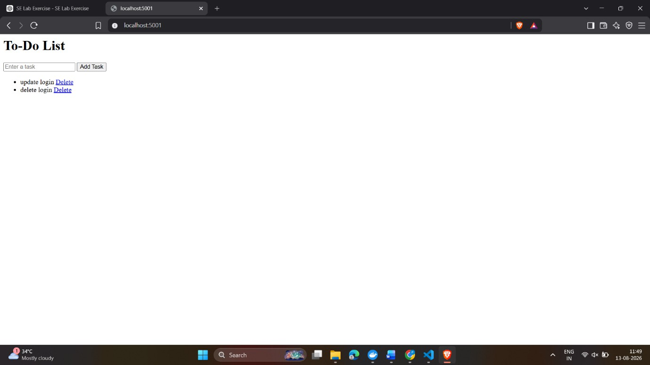

EXPERIMENT- 22

AIM:
Push and Pull Docker Images Using Docker Hub

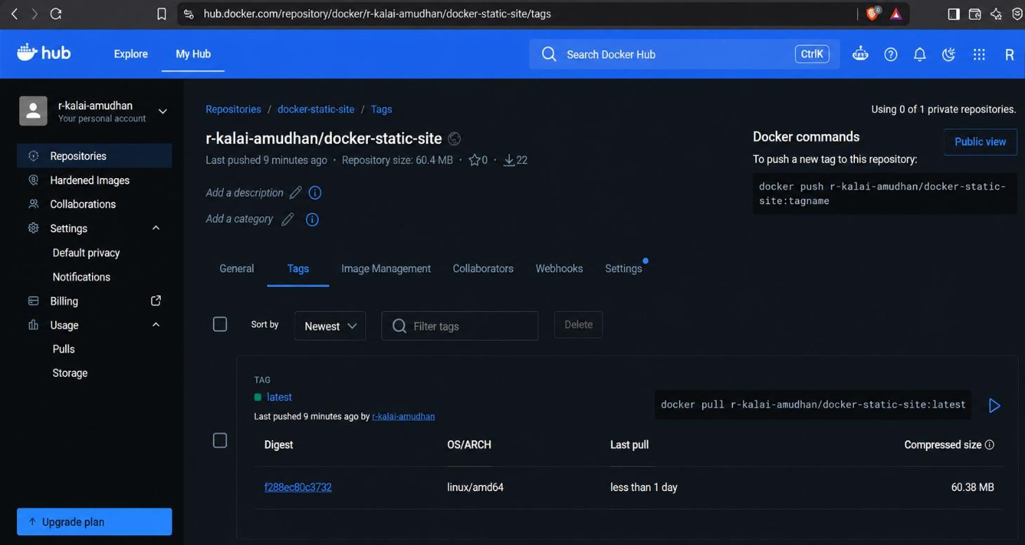

EXPERIMENT- 23

AIM:
Deploy a Multi-Container Application Using Kubernetes
